12.67: The escape speed will be

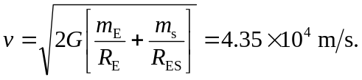
a) Making the simplifying assumption that the direction of launch is the direction of the earth’s motion in its orbit, the speed relative the earth is

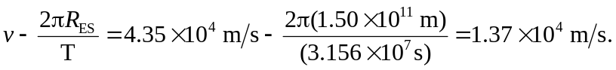
b) The rotational at Cape Canaveral is 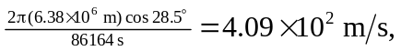 so the speed relative to the surface of the earth is 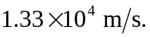 c) In French Guiana, the rotational speed is 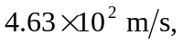 so the speed relative to the surface of the earth is 